SCons - Building Unit Tests
Introduction
A unit test executable file shall be compiled using the following files:
- Unit test source file (.c)
  - This file contains test case definition and function calls to the Cgreen library
- Code under test source file (.c)
  - This file contains code to be executed by the ARM target; the objective is to test the logic of the code in this file
- A bunch of header files (.h)
  - Most of the header files are from the embedded project. These header files are used only for their symbols.
  - The rest of the header files are from Cgreen
- Cgreen library shared object file (.so)
  - Required for load-time dynamic linking
  - Contains Cgreen library function definitions

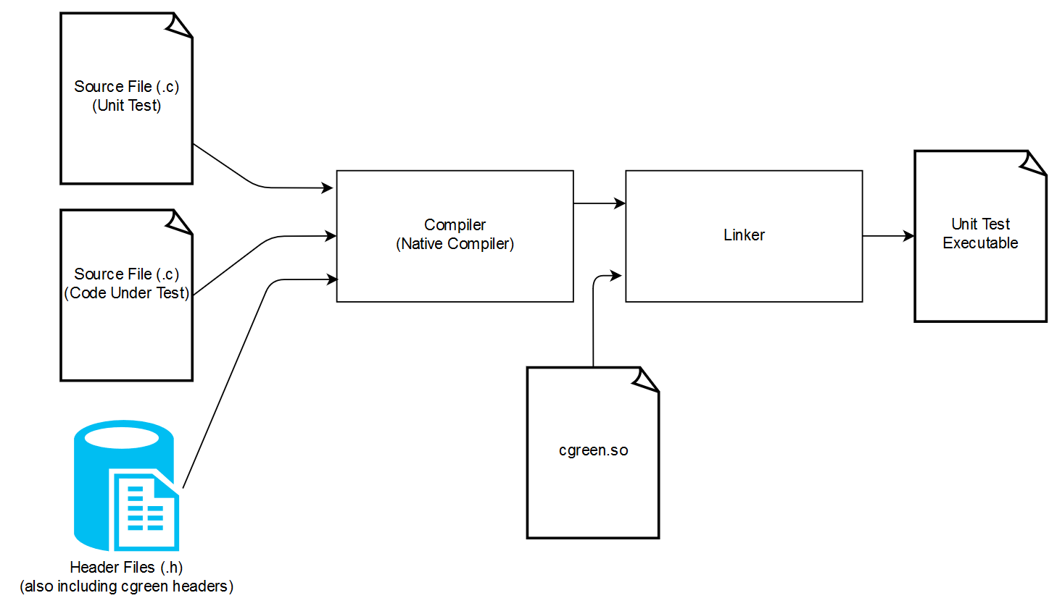

Unit Test - File Name Convention (not an official convention)
For example, the Sensors directory has the following source files in the image below. As a demonstration, I want to unit test bin_filt.cpp, a data set filter module.
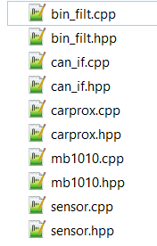
Files in foxp2/L5_Application/FOXP2/Sensor

SCons is set up to look for the file test_bin_filt.cpp in the directory foxp2/test, where test_ is prepended to the file of interest.
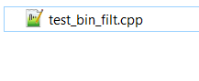
Files in foxp2/test/Sensor
Note, all files prepended with test_ located in the root directory foxp2/test or in a subdirectory will be built then executed automatically.

Unit Test - Building
Invoke SCons and build an ECU project with the option --unit_test
SCons will build then execute every unit test that exists within foxp2/test
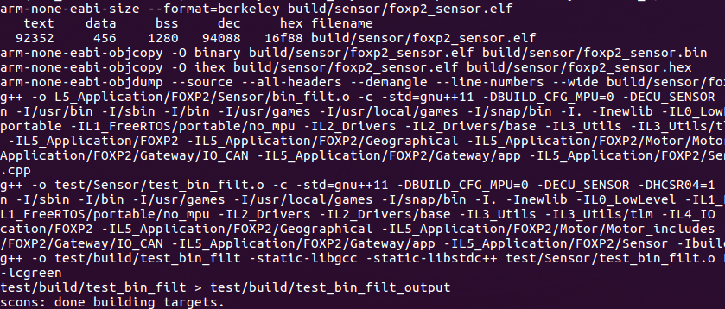
SCons pipes the executable’s standard out to a new file with _output appended to the name. The artifacts will be generated in foxp2/test/output.
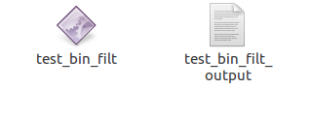
Files in foxp2/test/output

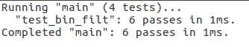
Content of test_bin_filt_output

Unit Test - Building (continued)
If at least one unit test fails (error code is non-zero), the SCons build will fail.
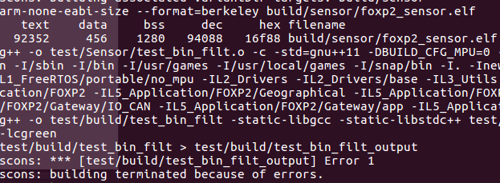

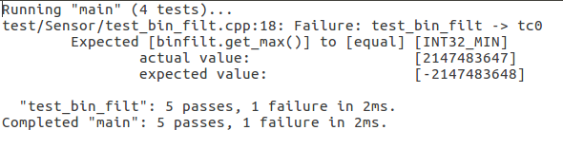
Content of test_bin_filt_output

Setup - Linux
Cgreen: https://github.com/cgreen-devs/cgreen
- Git clone to get source code files

- Follow instructions to build
- Or just run these commands:
- Modify the environment variable LD_LIBRARY_PATH to point to the shared object’s directory
SCons
ARM toolchain

Setup - Linux (continued)
Sublime (optional)

Setup - Windows
For Windows, I compiled Cgreen using Cygwin’s toolchain for x86 architecture; the produced linkable libraries are stored in the repository and are used during compile-time linking and load-time linking.

Cygwin Toolchain: https://cygwin.com/install.html
- Download the installer for x86 architecture (not x86_64)
- During installation, install at the default destination: C:\cygwin
- During installation, you will need to install additional packages:
  - Devel – gcc-core: GNU Compiler Collection (C, OpenMP)
  - Devel – gcc-g++: GNU Compiler Collection (C++)
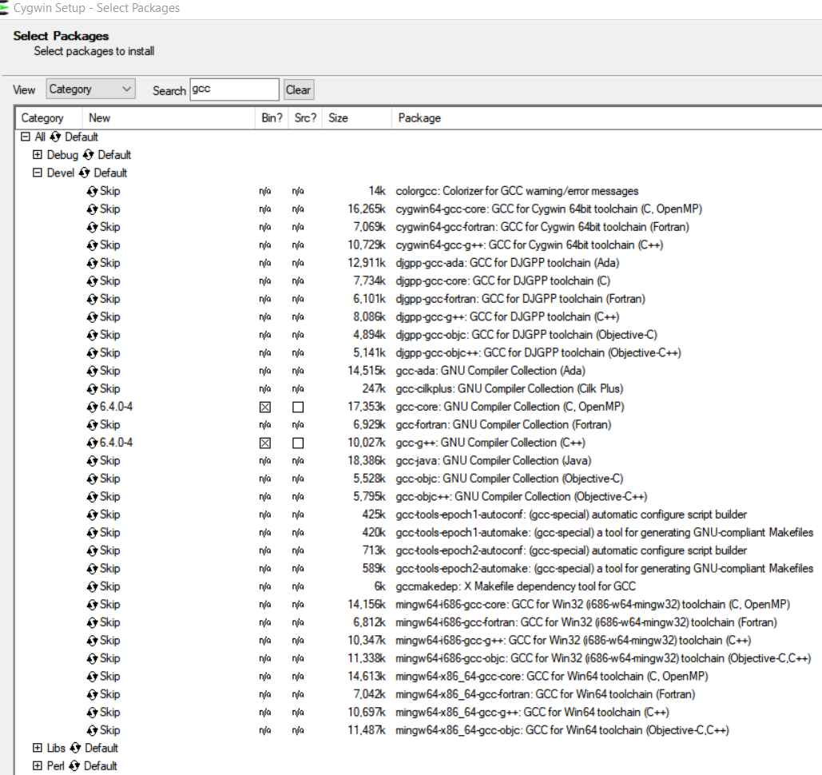

SCons: http://scons.org/

